**Department of Electrical Engineering and   
Computer Science**

**Faculty Member:** Dr. Huma Ghafoor  **Dated:** 23/02/2023

**Semester:** 6th **Section:** BEE 12C

**EE-351 Communication Systems**

Lab 4: RF Power Amplifier

Group Members

|  |  |  |  |  |  |  |
| --- | --- | --- | --- | --- | --- | --- |
| **Name** | **Reg. No** | **Viva / Quiz / Lab Performance** | **Teamwork** | **Ethics** | **Software Tool Usage** | **Analysis of data in Lab Report** |
|  |  | **5 Marks** | **5 Marks** | **5 Marks** | **5 Marks** | **5 Marks** |
| Muhammad Ali Farooq | 331878 |  |  |  |  |  |
| Danial Ahmad | 331388 |  |  |  |  |  |
| Muhammad Umer | 345834 |  |  |  |  |  |
| Tariq Umar | 334943 |  |  |  |  |  |

**Table of Contents**

3 RF Power Amplifier 3

3.1 Objectives 3

3.2 Introduction 3

3.3 Lab Report Instructions 3

4 Lab Procedure 4

4.1 Procedure A: Adjust Output Impedance 4

4.2 Procedure B: Input/Output Power and Power Gain 5

4.3 Procedure C: Antenna Power 8

4.4 Procedure A: Total, Carrier, and Sideband Power 8

5 Conclusion 10

**Table of Figures**

Figure 1: Carrier signal input to the calibration circuit 4

Figure 2: Antenna matching network output 5

Figure 3: Message and carrier signals 6

Figure 4: 100% modulated AM signal 7

Figure 5: 100% modulated AM (original and amplified) 9

# RF Power Amplifier

## Objectives

* We will learn RF power amplifier applications and its role in transmission.
* The AM Transmitter part will be completed with understanding the role of RF power amplifier applications.

## Introduction

To facilitate long-distance transmission of the message signal, it is necessary to increase its power. This can be achieved through the use of an RF power amplifier, which is an integral component of the communication circuit board. The power amplifier utilized in this setup is a common emitter amplifier. Additionally, an antenna matching network is employed to ensure maximum power transfer to a low impedance antenna. The antenna network operates on the principle of the maximum power transfer theorem, which asserts that the transfer of power is optimized when the source and load impedances are equal. The purpose of this report is to provide a detailed account of the design, implementation, and testing of the RF power amplifier and antenna matching network in the communication circuit board.

## Lab Report Instructions

All questions should be answered precisely to get maximum credit. Lab report must ensure following items:

* Lab objective
* Results (screen shots) duly commented and discussed.
* Conclusion

# Lab Procedure

## Procedure A: Adjust Output Impedance

1. Locate the AM/SSB TRANSMITTER and VCO-LO circuit blocks on the ANALOG COMMUNICATIONS circuit board, and connect the circuit shown in Figure 2-22(a). The VCO circuit block connects to the input of the 33052 CALIBRATION CIRCUIT: a two-post connector connects the 33052 CALIBRATION CIRCUIT to the ANTENNA MATCHING NETWORK, Figure 2-22(b) shows the schematic of this circuit. Set Si, S2, and S3 to OFF.

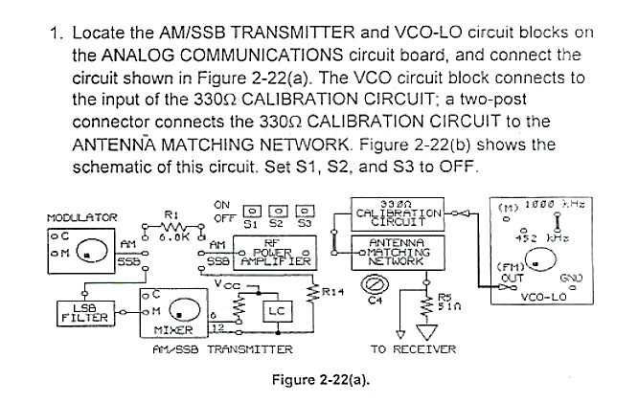

1. Connect the oscilloscope channel 1 probe to the input of the 3300 CALIBRATION CIRCUIT. While observing the signal on channel 1, adjust the VCO-LO output for a 200 mVpk-pk, 1 MHz signal at the input of the 3300 CALIBRATION CIRCUIT. Adjust the VCO-LO frequency with the NEGATIVE SUPPLY knob on the base unit, and adjust the amplitude with the knob on the VCO-LO circuit block.

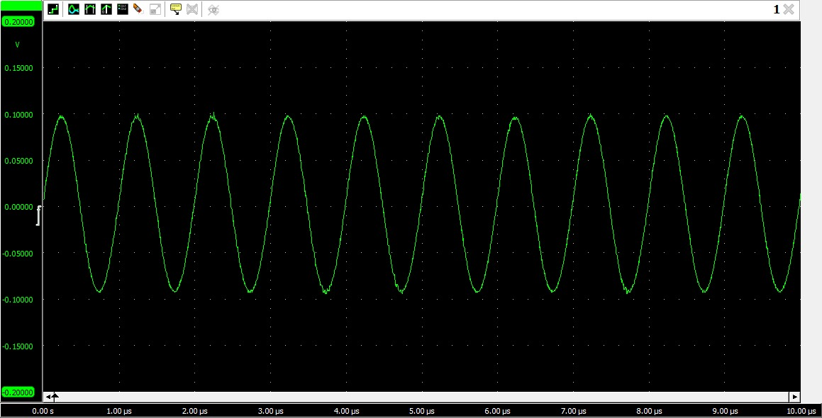

Figure : Carrier signal input to the calibration circuit

1. Connect the oscilloscope channel 2 probe to the input of the ANTENNA MATCHING NETWORK at L2.

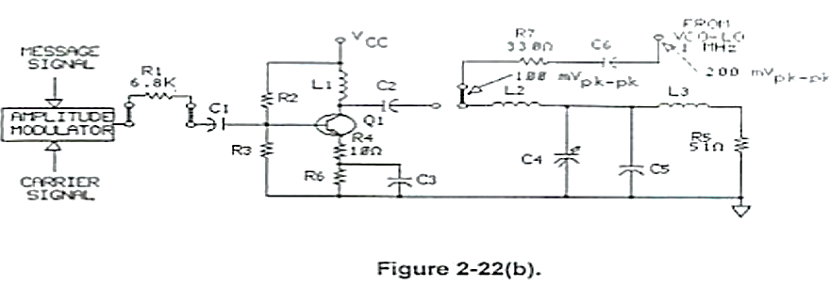

1. Adjust variable capacitor C4 so that the channel 2 ANTENNA MATCHING NETWORK signal is 100 mVpk-pk (half of the channel 1 signal).
2. The impedance of the 3300 CALIBRATION CIRCUIT is 3300. When the ANTENNA MATCHING NETWORK signal voltage (channel 2) is half the input signal voltage to the 3300 CALIBRATION CIRCUIT (channel 1), what is the ANTENNA MATCHING NETWORK impedance?

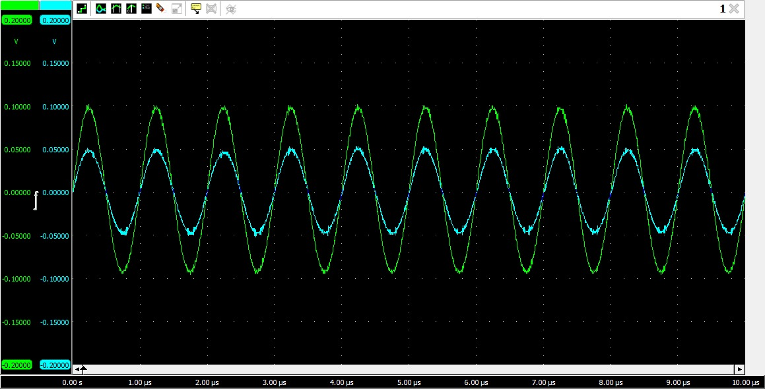

Figure : Antenna matching network output

**Answer:** Using voltage division, the impedance of the antenna matching network comes out to be 330.

## Procedure B: Input/Output Power and Power Gain

1. Set S1 and S2 to OFF. Set S3 to ON which will automatically set the ANTENNA MATCHING NETWORK impedance to 3300.
2. Connect the circuit shown in Figure 2-24(a). The circuit schematic is also shown in Figure 2-24(b). Connect the oscilloscope channel 1 probe to the MODULATOR carrier signal input (C).

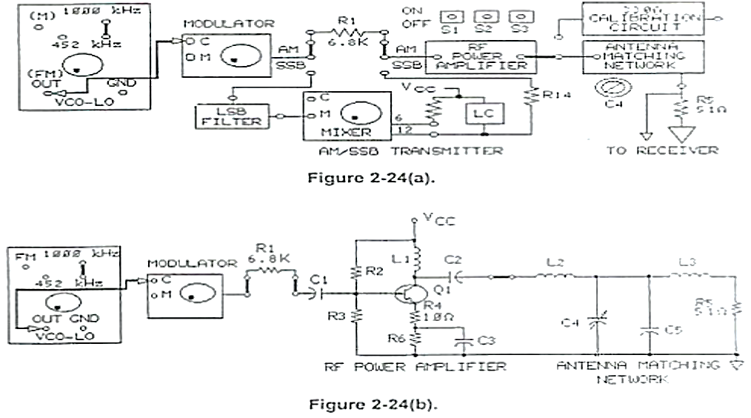

1. While observing the signal on channel 1. adjust the VCO-LO output for a 0.1 Vpk-pk, 1 MHz signal at the carrier input (C) of the MODULATOR. Adjust the carrier frequency with the NEGATIVE SUPPLY knob on the base unit, and adjust the carrier amplitude with the knob on the VCO-LO circuit block.

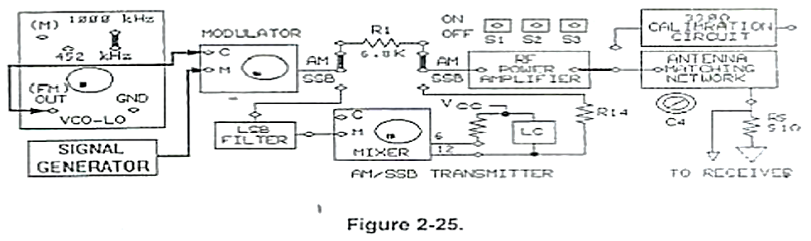

1. Connect the signal generator (Figure 2-25) and the oscilloscope channel 2 probe to the MODULATOR message signal input (M).

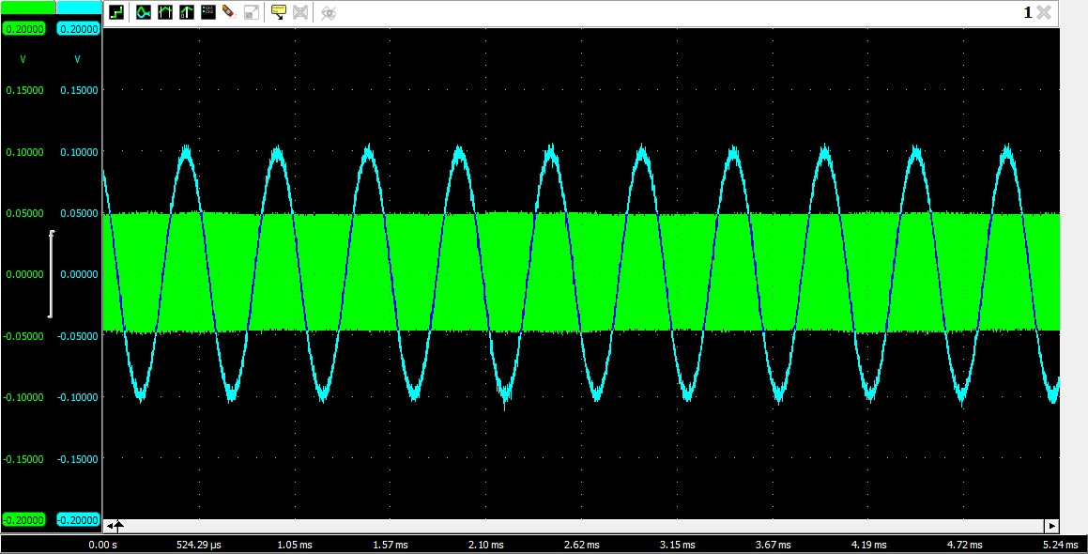

Figure : Message and carrier signals

1. While observing the signal on channel 2. adjust the signal generator for a 0.1 Vpk-pk. 2 kHz sine wave signal at the message input of the MODULATOR.
2. Connect the channel 1 oscilloscope probe to the output of the MODULATOR. Set the oscilloscope vertical mode to ALT and trigger on channel 2 (the message signal). Adjust the MODULATOR potentiometer knob so that the AM waveform is 100% modulated (refer to Figure 2-12 if you need to see what a 100% modulated signal looks like).

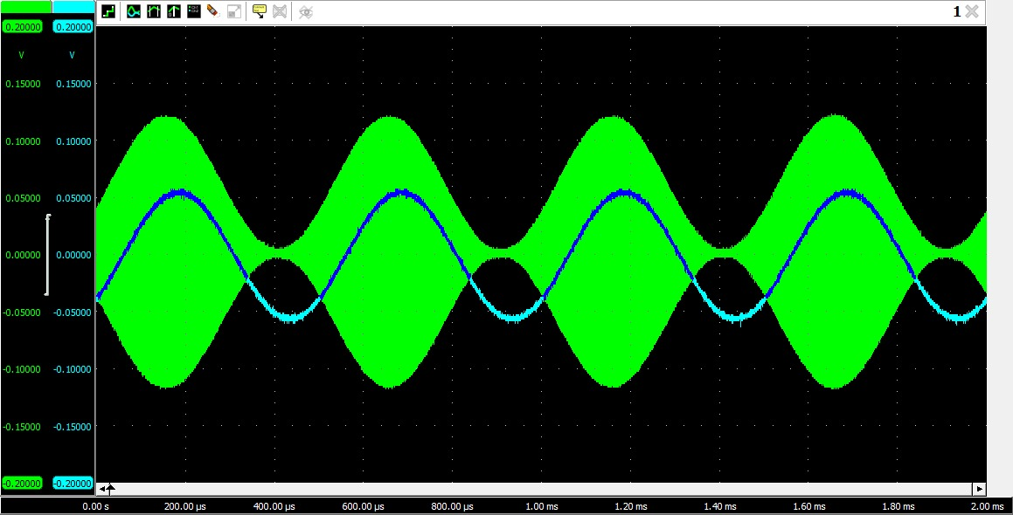

Figure : 100% modulated AM signal

1. You will observe and make RF POWER AMPLIFIER (01) measurements with just the carrier signal. Disconnect the signal generator from the MODULATOR message signal input (M).
2. Measure the voltage drop across R1 by using the ADD-INVERT method. Connect the oscilloscope channel 2 probe to the input (base) of the RF POWER AMPLIFIER (Q1). Set the oscilloscope vertical mode to ADD and the channel 2 polarity to inversion (INVERT). What is the R1 peak-to-peak voltage (VR1 (Pk-pk)).
3. Convert the VR1(pk-pk) value that you calculated in step 13 to a rms value. Use your result in the following equation to calculate the R1 rms current, which is also the current to the RF POWER AMPLIFIER (Q1).

**Answer: VR1pk-pk­**= 35.35 mV; **IR1** = 5 A

1. Set the oscilloscope vertical mode to channel 2 and the channel 2 polarity to noninversion. On channel 2, measure the peak-to-peak voltage (VQ1) at the input to the RF POWER AMPLIFIER.

**Answer: VQ1ipk-pk­**= 30 mV

1. Convert the V value that you measured in step 15 to a rms value. Use your result and the value you calculated in step 14 in the following equation to calculate the rms input power to the RF POWER AMPLIFIER.

**Answer: VQ1irms­**= 10.6 mV; **PQ1irms** = 53 nW

1. Connect the oscilloscope channel 2 probe to the input of the ANTENNA MATCHING NETWORK (RF POWER AMPLIFIER output). On channel 2. measure the peak-to-peak voltage at the RF POWER AMPLIFIER output (VQ1(pk-pk))

**Answer: VQ1opk-pk­**= 693 mV

1. The ANTENNA MATCHING NETWORK impedance. which is the RF POWER AMPLIFIER output impedance. is set to 330) Convert the VQ1(pk-pk) value that you measured in step 17 to a rms value Use your result and a load impedance of 330 to calculate the RF POWER AMPLIFIER output power.

**Answer: PQ1orms** = 185 uW

1. Calculate the power gain (Ap) of the RF POWER AMPLIFIER (Q1).

**Answer: AP** = 3500 W/W

## Procedure C: Antenna Power

1. Set S1 and S2 to OFF. Set S3 to ON.
2. Connect the oscilloscope channel 2 probe across the antenna load (R5) and measure the voltage.

**Answer: V­­R5pk-pk** = 222 mV

1. Using the value of V that you determined in step 21 and an antenna load impedance of 51, calculate the antenna power.

**Answer: Pa** = 0.121 mW

1. Using the PQ1 value that you calculated in step 18 of PROCEOURE B and the P value you just calculated in step 22, calculate the percentage of RF POWER AMPLIFIER output power that is transferred to the antenna (R5).

**Answer:** The %age RF power transferred to the antenna is 65.4%.

## Procedure A: Total, Carrier, and Sideband Power

1. Set S1 and S2 to OFF. Set S3 to ON.
2. Connect the signal generator to the MODULATOR message signal input (M). The message signal should be 0.1 Vpk-pk at 2 kHz.
3. Connect the oscilloscope channel 2 probe to the input of the ANTENNA MATCHING NETWORK (RF POWER AMPLIFIER output). Adjust the oscilloscope so that you can observe the AM signal. Is the AM signal 100% modulated (with a modulation Index of 1)?

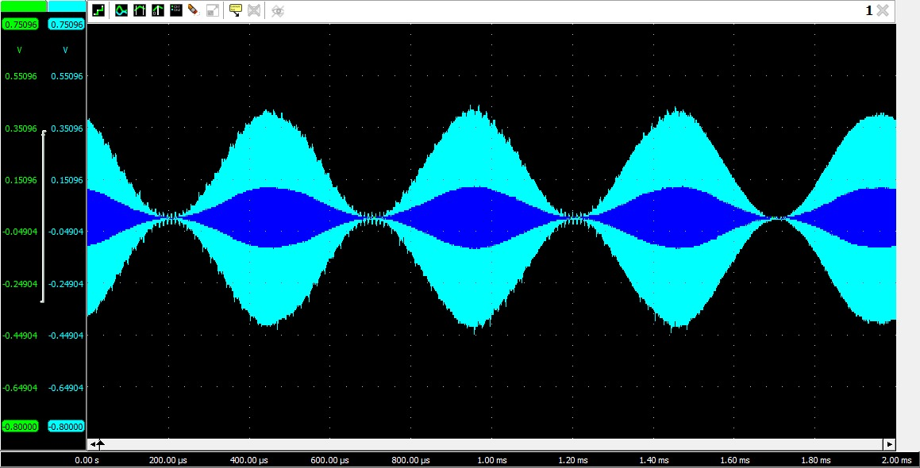

Figure : 100% modulated AM (original and amplified)

**Answer:** Yes, the signal is 100% modulated, as apparent from the figure.

1. The total AM signal power (PT) is related to the carrier power PC by the modulation index in the following equation.

PT = PC + (PC x m2)/2

1. Using your calculated Pc from step 18 in PROCEDURE B and the modulation index of 1.0, calculate the total power.

**Answer: PT** = 0.277 mW

1. The total AM signal power equals the carrier power plus the sideband power. Calculate PSB using the P1 value you just calculated in step 28 and the PC value you determined in step 18 of PROCEDURE B.

**Answer: PSB** = 92 uW

1. At 100% modulation, what is the percentage of upper and lower sideband power in the total AM signal power?

**Answer:** The percentage of upper and lower sideband power in total AM power is 33.33%.

# Conclusion

In conclusion, the RF power amplifier and antenna matching network play critical roles in ensuring successful long-distance transmission of the message signal. Through careful design and implementation of the power amplifier and matching circuit, we were able to achieve optimal power transfer to the low impedance antenna, which resulted in improved signal quality and transmission distance. The results of our testing demonstrate the effectiveness of the RF power amplifier and antenna matching network in increasing the power of the message signal and extending its range.